**Answer of Optional Project**

**While working on this dataset I have used Pivot Table to obtain all the insights from it.**

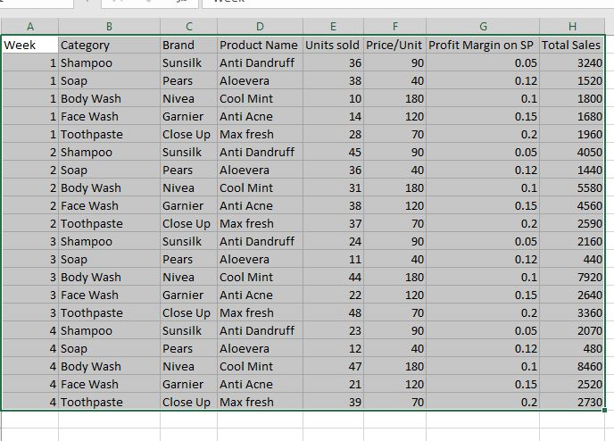

1. **Week Wise Sales**

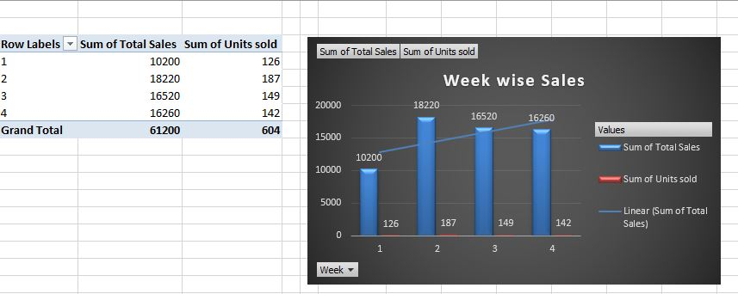

**From the above diagram I have used column chart to define Week Wise Sales in a better manner.**

**In this I can see 187 units sold in a week with 18220 sales value.**

1. **Total Sales on category**

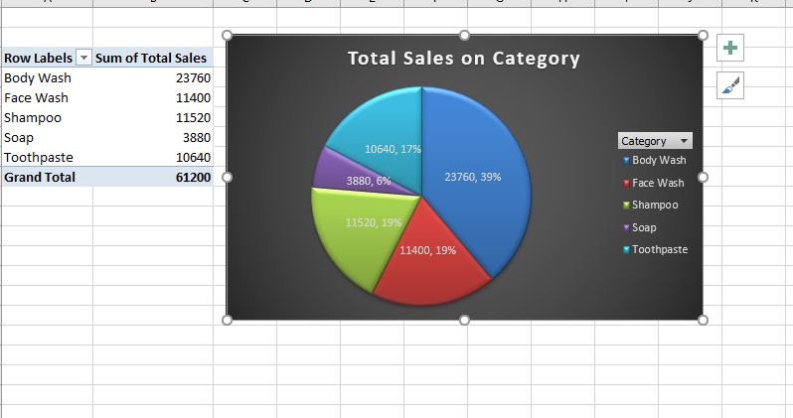

**From the above pictures I have find out Total sales on Category by using Pie Chart which shows Body Wash has the major sales with 23760 value.**

1. **Product Wise Sales**

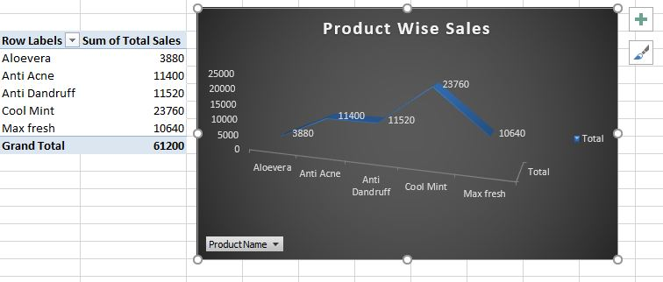

**From the above diagram it shows that Cool Mint has the sale value of about 23760.**

1. **Brand Wise Sales**

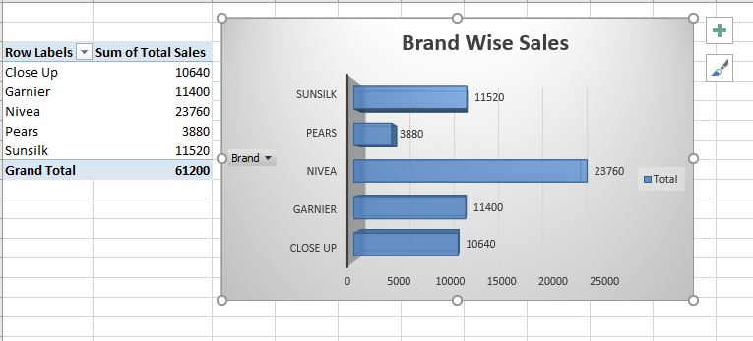

**From the above image it shows that Nivea Brand sales is 23760.**

1. **Category Wise Units Sold**

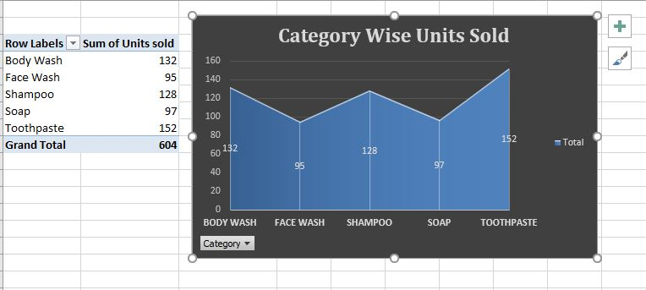

**From the above Area chart Toothpaste is the leading product to be sold with 152 units in it.**

1. **Brand Wise Units Sold**

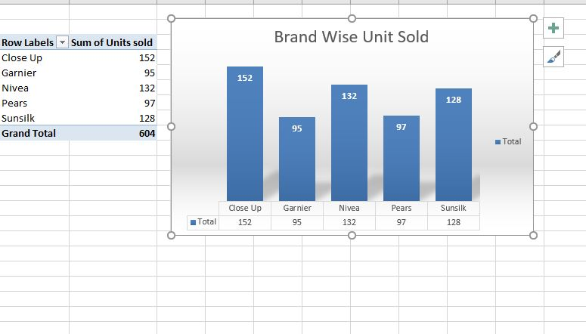

**Nivea is the leading Brand wise unit sold in this dataset with 132 units sold.**

1. **Total Sales & total units sold**

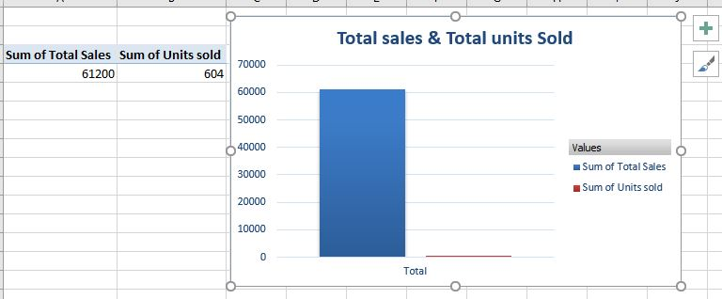

**I have shown the total sales & total units sold with Column chart which Shows that,**

**Total sales is 61200**

**Total units sold is 604**